Title of article

(The title should be in 13 font size, Tımes New Roman, Bold, Sentence Case, and Centered)
Author 1 first name and surname*¹, Author 2 first name and surname², etc. (indicate all authors)
¹Author 1 Affiliation (Contact Address)
²Author’s Affiliation (Contact Address)
*Corresponding author’s email address

(The author names should be 11 font size with the author affiliation information in 10 font size as indicated above, but they should all be in Times New Roman, and Centerred. Also, use asterisk to highlight corresponding author)

Abstract
Authors should insert or type in their abstract under this section. All manuscripts should start with an abstract after the title page. The abstract heading should be typed in bold 12-point font size Times New Roman, and the text should be in 11-point font size Times New Roman and justified. Typically, the abstract should include the significance, aim, main method(s) and key findings of the work in the manuscript. The abstract should be a maximum of 250 words for all article types except profiles and editorials, which should be a maximum of 120 words. The abstract should normally not contain any undefined abbreviations.

Keywords: Maximum of six (6) words should be listed here separated by commas in font size 11.

Introduction
The manuscript must always have an Introduction section as the first section of the main text after the keywords. The content of this section should commonly include a brief background, short review of the pertinent literature in the study field, and the purpose, significance and possible contribution of the study or research work. The heading of this section and all main headings in the manuscript should be in 12 font size, Times New Roman, bold, and sentence case. The page format should be A4 paper size with 2.5 cm wide margins from the right, left, top and bottom. Indents should be used when starting a new paragraph.

Materials and Methods
This section must provide clear sufficient information on the experimental procedures, investigations, measurements, and analyses employed in the study to permit repetition of the work. Commonly, modifications made to known employed methods must be clearly explained. However, if already known methods are simply employed in the study, then appropriate reference(s) must be made to them instead of re-producing the known details. Also, a description of the study area including a detailed map, where applicable, must always be provided under this section. The theory and practice behind the methods, and the reasons for selecting the methods must also be provided.
The section heading could be named differently, and with subheadings and sub subheadings, depending on the nature of the study, but the overall content should always refelect the employed methods in the study. Subheadings should be typed in 11 font size Times New Roman, bold, italic and sentence case with sub subheadings also in the same format but not bolded.

Results and Discussion
The results and observations from the study and their detailed interpretations should be presented under this section. The results should be presented in tables or figures, whenever possible, while their interpretation, significance, and limitation(s) in comparison to relevant contemporary studies are to be clearly explained in the text. In a situation where authors wish to have separate Results and Discussion sections, it must be ensured that the results are not repeated under the discussion section. Also, subheadings could be introduced under this section when needed.
Tables and Figures (including pictures, maps, photos, and charts) should be inserted at appropriate positions where needed in the manuscript and numbered sequentially in the order in which they are referred in the text (example: see Figure 1 and Table 1). The figure captions should be placed under the figure whereas the table captions should be placed on the top of each table. Captions for all the tables and figures should be typed in 10-point font size Times New Roman in single line spacing. Footnote markers for tables should be consecutive superscript lowercase letters (or asterisks for statistical data) and explained beneath the table body in 9-point font size Times New Roman in single line spacing. Similarly, displayed equations in the manuscript should be generated using Microsoft Word Equation Editor or any equation editor that works in MS Word, numbered sequentially at the right-hand margin in parenthesis and referenced in the text.

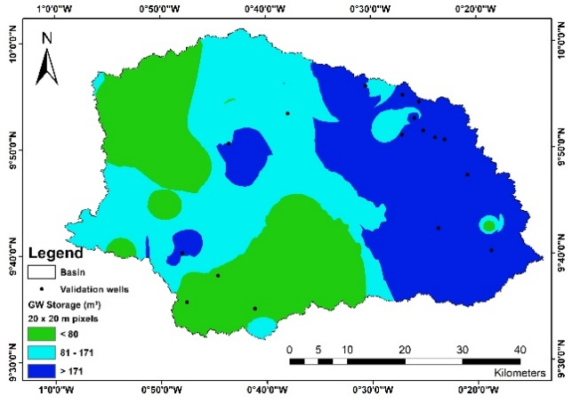

Figure 1 Groundwater storage volume in the Nabogo basin

Table 1 Projected water consumptions (m³/day) in Nabogo basin for the years 2018 and 2048

Category | 2018 | 2048
Domestic | 20,630 | 48,636
Cattle | 4,595 | 6,509
Sheep & Goat | 2,449 | 10,490
Poultry | 990 | 42,219
Total | 28,664 | 107,853

Conclusions
This section should provide a summary of the study objective, methods, key findings, implications for policy, and any proposals for further work. It must be emphasized that a manuscript submitted for publication must be a maximum of 7500 words for all article types except profiles and editorials, which should be a maximum of 3000 words. Automatic page numbering and continuous line numbering should be applied for all the pages of the manuscript excluding the title page.

Acknowledgement
This section is for acknowledging the funders and any other person(s) or organisations who supported the work. The names of funding organisations and institutions should always be written in full under this section.

Conflict of Interest Declarations
Authors need to disclose any commercial or associations that may pose a conflict of interest in connection with the submitted material under this section.

References
All the references in the manuscript should be cited using the author(s) and year in parentheses format and listed alphabetically. The formatting style for listing the various sources of references should be as follows for:

(a) Books
Last name, other names initial (for all authors). (Year). Title. City of publication: Publisher.
For example:
Kesse, G.O. (1985). The mineral and rock resources of Ghana. Rotterdam: AA Balkema Publishers

(b) Book Chapter

Last name, other names initial (for all authors). (Year). Chapter title. In: Editor's name(s) (ed/s), Book Title. Edition. City of publication: Publisher, Page(s).
For example:
Tsikata, F.S., Brew-Hammond, A. and Osafo, Y.B. (2008). Increasing access to clean energy in Ghana: challenges and initiatives. In: Zilmann, D.N., Redgwell, C., Omorogbe, Y.O. and Barrera-Hernandez, R.K. (eds.), Beyond the carbon economy: energy law in transition law. New York: Oxford University Press Inc., pp. 163-177.

(c) Journal Articles
Last name, other names initial (for all authors). (Year). Article title. Journal name, Volume (Issue), Page(s). DOI (if available).
For example:
Tufour, E. O. A. (2022). Optimum axle load limit on the trans west African highway – a case study of Ghana’s coastal corridor. Journal of the Ghana Institution of Engineering, 22 (1), pp. 16-22. https://doi.org/10.56049/jghie.v22i1.7.
Appiah-Adjei, E. K., Shu, L. C., Adjei, K. A., Lu, C., and Deng, M. (2012). Interpretation of pumping test with a radial collector well using a reservoir model. ASCE Journal of Hydrologic Engineering, 17(12), pp. 1397-1407.

(d) Newspaper and Magazine Articles (whether print or online):
Last name, other names initial (for all authors). (Year). Article title. Newspaper or Magazine name, Volume (Issue), Page/s. Available at: URL link [Accessed date] if available.
For example:
Cardigah, V. K. (2022). Agriculture, Ghana’s industrialization. Daily Graphic. Available at: https://www.graphic.com.gh/features/opinion/agriculture-ghana-s-industrialisation.html [Accessed 25 November 2022].

(e) Reports (consultancy, project, thesis, or any technical report):
Author/Organisation’s name. (Year). Title of report. Type of Report, Publisher, City of Publication.
For example:
Osei-Nuamah, I. (1998). Hydrogeological evaluation of formations in Ashanti Region, Ghana.
Master Thesis, Kwame Nkrumah University of Science and Technology, Kumasi.

(f) Online Sources (citation of information on websites):
Author or Source if no specific author is provided (Year). Title of web document/page. [online]. Available at: URL [Accessed date: Day/Month/Year].
For example:
Health Tips (2015). Superfoods and where to find them. [online]. Available at: www.healthtipsarticles.com/superfoodsandwheretofindthem [Accessed 20 June 2016].

